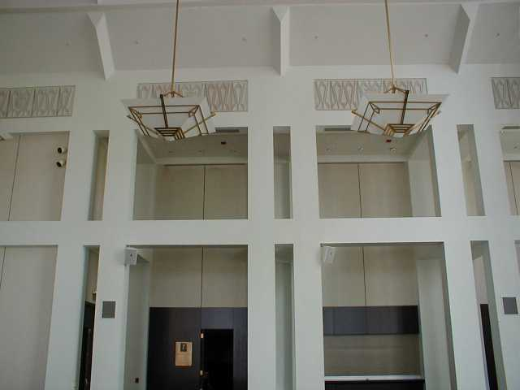

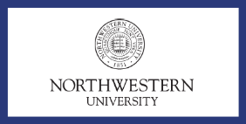

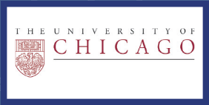
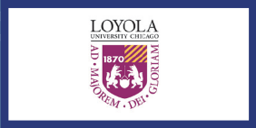
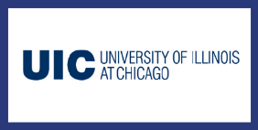
UNDERGRADUATES OF ALL YEARS ARE INVITED TO ATTEND, VOLUNTEER, AND PARTICIPATE
FACULTY, STAFF, STUDENTS, AND FRIENDS ARE ALL WELCOME: RSVP INFO@CAURS.COM
www.caurs.com
Chicago Area
Undergraduate Research Symposium

Northwestern University • University of Chicago • University of Illinois at Chicago

DePaul University • Illinois Institute of Technology • Loyola University
PRESENT YOUR RESEARCH
ABSTRACTS DUE: MARCH 30

IPOD NANO RAFFLE FOR SUBMISSIONS ON OR BEFORE MARCH 2

Opening Speaker:
Loyola President Michael J. Garanzini, S.J.
Research Speaker:
Dr. Thomas Meade of Northwestern University
Keynote Speaker:
Dr. John Muraskas of Loyola Medical School

Host: Loyola University, Kasbeer Hall
25 E. Pearson St., Chicago
biology
engineering
physics
mathematics

chemistry
psychology
and more

POSTER PRESENTATIONS & RESEARCH TALKS:

ATTEND: OPENING ADDRESS, INVITED LECTURE, KEYNOTE, DINNER AND AWARD CEREMONY
CASH PRIZES FOR TOP ABSTRACTS, POSTERS, TALKS, & RESEARCH PROPOSAL

Saturday,
April 14, 2007

